**I. Executive Summary**

**Unique Value Proposition:**

Raising Cane’s has an incredibly unique business model in the way that its menu is extremely simple, offering only their One Love: quality chicken finger meals. This simple menu offers a unique twist on the philosophy of having something for everyone. Why offer something specific that only a few people will enjoy, when you can perfect one item that everybody will love? This simple philosophy alongside their crispy, juicy, golden brown chicken tenders have attracted incredible results since their opening in 1996, making them one of the fastest growing fast-food chains in America.

**Management Team:**

Our Raising Cane’s management team will consist of 3 managers: a kitchen manager, a front-of-house manager, and a general manager. The managers will consist of our very own Jayden Lazarus as a general manager ensuring the location runs smoothly, a kitchen manager who will oversee the operations of our seven-kitchen staff, and a front-of-house manager who will oversee the operations of our three cashiers and bussers as well as our dining room operations. Ideally, each of these two positions will be filled by individuals with a minimum of five years of working experience in the restaurant industry as well as a minimum of one year of working experience in the restaurant industry.

**Environment:**

Our Raising Cane’s restaurant will be located at 1207 Southeast 17th Street, just outside of downtown Fort Lauderdale, Florida. Fort Lauderdale is one of the most popular tourist destinations in Florida. Many people are astonished by the city’s beautiful beaches, amazing culture, and fun events. Our location is situated just a couple minutes away from 595 and I95, two major highways in Florida. This will allow customers fast and easy driving access to our restaurant.

**Competitive Advantage**

The new location will have a large advantage over its competition due to its location, being the fact that the restaurant will be at one of the busiest intersections in Broward County both by general traffic and tourist volume. This is due to the intersection being the main artery between the Fort-Lauderdale Hollywood International Airport, I-595, and I-95 to Fort Lauderdale beach, the Broward County Convention Center, and Port Everglades. This provides a large amount of both tourist and local traffic, allowing us to cash in on the large food expenses the tourism industry creates as well as the local economy’s demand for fast food.

**Marketing:**

Through the use of popular social media platforms such as Tik Tok, Instagram, and Facebook, we will promote the opening of our location. By doing this, we are presenting our restaurant to a mainstream audience, as all Raising Cane’s social media accounts have garnished a follower count of over 400,000 people. After our second year of operation, we will begin hosting various community events, such as beach clean ups, charity walks, chicken eating competitions, and much more. These events will get local people excited and want to visit our location more.

**Performance Indicators**

As Raising Cane’s is privately owned, it is not possible to judge the performance of the company through their stock prices. Instead, performance will be based on growth and sales trends for the company as a whole and customer satisfaction surveys and sales data for our specific location. Survey data will be provided by offering customers a free box combo on their next visit by signing up customers to the Raising Cane’s Caniac Club in return for completing a brief survey on the bottom of their receipt. Performance will also be gauged through monitoring third-party customer review apps such as Yelp to have access to a wider range of data.

**Target Market:**

|  |  |
| --- | --- |
| **Demographics** | * Primary market consists of people between the ages of 16 to 34 * People with an annual income of $20,000 or more |
| **Psychographics** | * Those who value freshly made chicken fingers * People who enjoy family friendly dining experience |

**Financial Details:**

|  |  |
| --- | --- |
| **Personal investment** | A total of $150,000 will be personally invested by franchisees Kyle Hanson, Jorge Valdez, and Jayden Lazarus ($50,000 per person) |
| **Bank Loan** | We will acquire a Small Business Administration loan of $3 million at an interest rate of 2.75% that will be paid off over a 10-year span. |

**Growth Potential:**

**Exit Strategy:**

Afterthe 10-year Raising Cane’s franchise agreement has ended, we will sell the franchise location to a new owner that is fully capable of running the restaurant. After these ten years of operation, the restaurant will have made a large amount of profit. By then, the Small Business Administration loan would have been fully paid off.

**II. Business History, Background, and Objective**

1. **Describe the company you wish to purchase franchise rights**

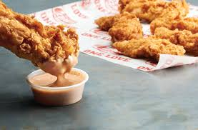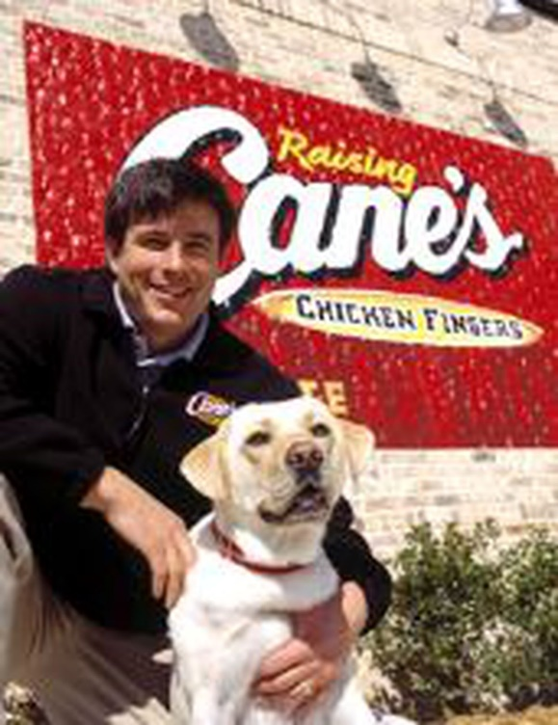After getting a horrible grade on his business plan for a college class and being rejected for a loan by every bank in Los Angeles, Todd Graves was still devoted to making his dreams of opening a chicken fingers restaurant a reality. To make money, Graves worked 90 hours a week as a boilermaker in the Los Angeles Refinery and later worked 20-hour days in vicious conditions as a commercial Sockeye Salmon fisher in Alaska. When he arrived home, he used the money he earned to acquire a Small Business Administration loan and opened the first Raising Cane’s restaurant on August 28th, 1996, in Baton Rouge, Louisiana. Today, Raising Cane’s is a multimillion-dollar company with more than 560 locations across 30 states. All Raising Cane locations are well known for their polite crew members, active community involvement, exciting culture, and (of course) their chicken fingers. Unlike many other popular fast-food chains, Raising Canes chicken is fried fresh and lacks any greasy texture. The restaurant only uses chicken breast tenderloins, which is the underside of a chicken breast and is considered the premium piece in the poultry business. The products are fresh and never frozen when cooking. In addition to chicken fingers, Raising Cane’s also sells Chicken Sandwiches, crinkle-cut french fries, coleslaw, texas toast, and various fountain drinks. Raising Cane’s is active in various community organizations such as schools, pet welfare, youth sports leagues, faith-based organizations, and many more.

Figure 1: The founder of Raising Cane's with the dog that inspired the name

Figure 2: Raising Cane's famous chicken fingers

1. **Short-term and long-term objectives**

|  |  |  |
| --- | --- | --- |
| **Year 1** | **Years 2-3** | **Year 4** |
| -Opening our location in Fort Lauderdale  -Hiring employees and putting them through extensive training  -Promote the new location through various social media platforms | -Host various community events at Fort Lauderdale beach  -Partner with online delivery services (such as Grubhub, Postmates, etc.)  - Improve security measures | -Implement catering services for special events  -Introduce a salad to the menu |

Our major short-term objective will be to open the Raising Canes facility in the location of choice. This location will be on the southwest corner of South Federal Highway and Southeast 17th Street in Fort Lauderdale, Florida. The reason we chose this location is because it is proximity to both Fort Lauderdale Beach and a popular cruise port. This means that large numbers of people will be travelling around this location, therefore major profit can be made. After the location is fully built, we will hire 15 staff members and put them through extensive training for them to perform to the best of their ability. The training will consist of the staff members being taught how to use the equipment and where everything can be found throughout the restaurant. We will then take to popular social media platforms, such as Instagram, Facebook, and Twitter, to promote the new location and to drive in customers. For the second year of operation, we will host various community events on Fort Lauderdale beach, such as beach clean ups and charity runs. Not only will these events help the local community, but it will also spread awareness of the new location. We will also be applying more security measures so that both customers and staff members can feel safe. For our third year of operation, we will partner with popular delivery services (Uber Eats, Grubhub, and Postmates) to further expand our market. For the fourth year of operation, we will implement a catering service that will distribute Raising Cane’s food to special events. We will also be adding a salad to the menu to further diversify the menu and appeal to a more health-conscious market.

1. **Describe the Company’s Major Successes and Achievements to Date**

Throughout its 31 years of operation, Raising Cane’s has received numerous honorable titles. In 2002, Raising Cane’s was honored as an “Emerging Concept” at the Elliot Conference in New York. In 2003 the restaurant was announced the winner of the “Hot Concept!” award by Nations Restaurant News. Raising Canes then received the National Restaurant Association’s Good Neighbor Award in 2006. On February 19th, 2020, Thrillist, a popular lifestyle media website with over 25 million readers, ranked Raising Cane’s chicken as the number one fast-food chicken tenders. This was a phenomenal feat for Raising Cane’s. The decision was based off four features of the chicken: breading, seasoning, tenderness, and overall-taste.

1. **Describe the company’s challenges and obstacles**

The most notable issue the company faced was the founder’s difficulties in sourcing funding to start the company. Mainly, many people believed that a company that only sold chicken tenders would fail. This included the founder’s college professor who gave Graves a failing grade for submitting the idea for Raising Cane’s as a business plan, as well as the banks who shared the same views as the professor. This forced Graves to work to build his own capital to take out a Small Business Administration loan to open his first location. Eventually, his 90-hour work weeks paid off when he opened his first location on the doorstep of Louisiana State University. The customer turnout of opening day was so positive, the restaurant had to stay open until 3:30 in the morning to finish serving their customers. This was only a sign of what was to come, as they have grown from that one location in 1996 to earning over $1.18 billion in sales across 400 locations across the southern U.S. Throughout 2020, various restaurants and fast-food chains were being negatively affected by COVID-19, however Raising Cane’s was one of the few that was striving during the pandemic. As stated by the CEO of Raising Canes, Todd Graves, during an interview with Yahoo!News on April 15, 2021, “... we actually did better throughout the pandemic because of our drive-through's.”

1. **Describe the requirements to franchise**

A potential Raising Cane’s franchise will require multiple costs in operations and startup fees. To acquire the license, potential franchise owners must provide $45,000. After acquiring the rights, startup costs are estimated to be $768,000 to $1,938,000. These costs will cover space rental, staffing, inventory, and equipment for the franchise during the initial three months of operation. The potential franchise will be required to cover costs of operations for long-term sustainment while providing 5% of revenue in royalty fees, as well as an additional 4% of revenue in advertising fees to corporate. In addition to the fees required, a franchisee must have a working capital of $90,000 to $250,000.

**III. Business Environment**

Overall market trends show that both social and economic factors would support the growth of our franchise. This is primarily due to the positive growth of the tourism industry as well as the overall economy of the Fort Lauderdale area. This can be seen in the increasing demand for products tying back to the travel and tourism industry, with the Fort Lauderdale - Hollywood International Airport seeing a 20% increase in passengers over last year and nearly 8,000 hotel rooms in the pipeline for the Fort Lauderdale area. Considering the location would be in close proximity to the port, growth of the tourism industry in the area is expected to make a much greater rebound once complications with COVID-19 can be resolved within the cruise industry. Social factories would also impact our franchise in a positive way, as many individuals are choosing to make chicken more dominant in their diet for different health and environmental reasons. This is evident in a report from Forbes that illustrates the trend perfectly, with Americans on average eating 61 pounds of chicken per person in 1990 growing to an estimated 98.5 pounds of chicken per person in 2020.

|  |  |
| --- | --- |
| Political | Fort Lauderdale is a somewhat liberal city that is always open to new opinions and values. The city is operating under a strong Commission-Manager form of government. |
| Economic | Due to labor shortages created by the COVID-19 pandemic, there is more competition than ever when it comes to finding qualified employees. This means predicting job applicants will be unpredictable, and we may have to offer improved incentives to entice new hires. |
| Social | Despite not having any locations in South Florida, it is well known in the Fort Lauderdale area. This is especially true in younger demographics, as Raising Cane’s has been receiving major praise on the popular social media platform Tic Tok, and when combined with Fort Lauderdale being no exception to the Southern addiction to fried chicken it will make it easier to introduce this otherwise niche fast food chain into a new market for the company. |
| Technological | Considering Fort Lauderdale is a hub for technology companies, it may make it easier to get access to a wider array of systems to keep track of sales and overall profits. State-of-the-art security systems could also be implemented into our location. |
| Legal | There are various amounts of buildings for sale near the location we chose. The one in which we will be purchasing is a building located at 1207 Southeast 17th Street, Fort Lauderdale, Florida. The building was previously a PDQ restaurant, meaning it already has the layout of a restaurant, we just must remodel it and add furniture. |
| Environmental | Fort Lauderdale is an unusually health-conscious market which will both aid and hinder. This is because many Americans are making a shift away from red meat to include more chicken in their diets, however the health-conscious market of Fort Lauderdale may be less attracted to a menu of nothing but fried chicken. We will solve this issue by adding a new salad to the menu, something that’s nice and manageable so it will not botch the simplicity of the Raising Cane’s menu. |

**IV. Products and/or Services**

1. **List and describe the products and/or services offered**

Products that each franchise is equipped to provide customers includes food options such as their premium chicken breast tenderloins that are transformed into the iconic chicken fingers using their special marinade for tenderization and flavor, then fried in premium quality canola oil. In addition to this, there are also crinkle-cut fries that are center-cut from Grade A potatoes that are then cooked to a golden-brown crisp. There is coleslaw made from a simple blend of cabbage, carrots, and dressing, texas toast that is cooked to order from sesame seeded pull-apart 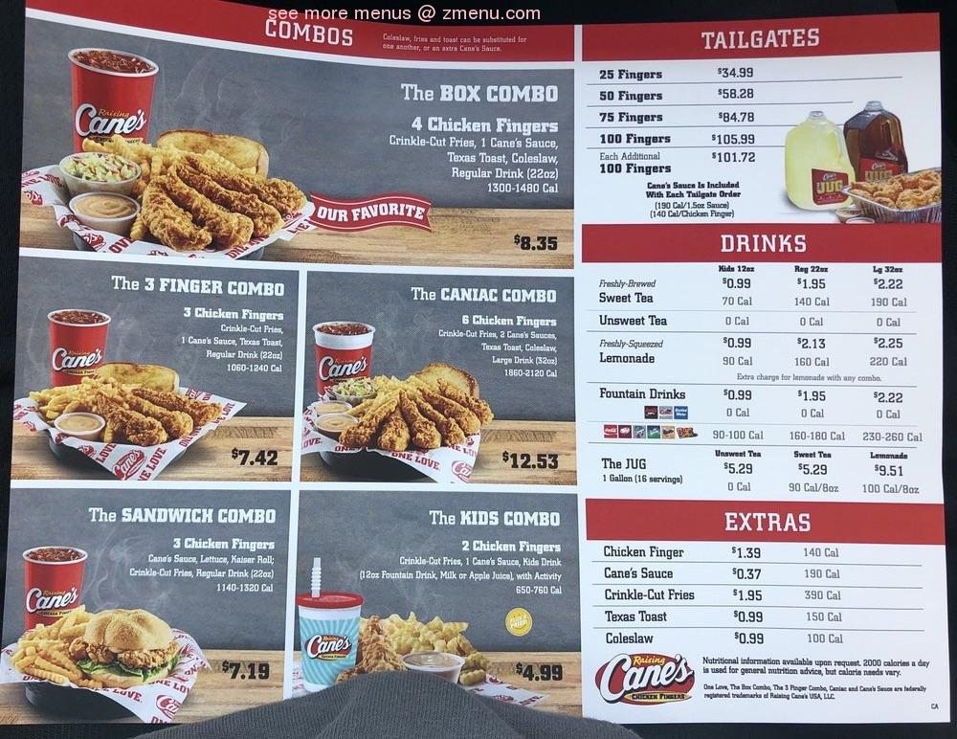bread, then brushed with the perfect amount of butter and garlic. And the final quintessential ingredient is the signature Cane’s sauce that is tangy with a little bit of spice and punch of flavor made with a secret blend of seasoning and spices that is made daily in the kitchen. Raising Cane’s is partnered with the popular food delivery service GrubHub so that customers can have the best chicken fingers in America delivered straight to their doorsteps. Raising Cane’s also has a mobile app, referred to as the Caniac Club, where customers can make their orders and come to the nearest Raising Cane’s restaurant to pick it up. The app also awards its customers with various gifts on special dates, such as a free drink on the user's birthday and special food rewards on the user’s Caniac Club anniversary or special holidays.

Figure 3: Raising Cane's menu example

**V. Present Market**

1. **Describe the present market**

|  |  |
| --- | --- |
| **Demographics** | - Ages 16 to 34  - Income $20,000+ |
| **Psychographics** | - Enjoy freshly made chicken fingers cooked to perfection  - Enjoy friendly service |
| **Geography** | - Located throughout the East and South United States  - The most locations are found throughout Texas |

Our primary target market will consist of people between the ages of 16 and 34. As seen on the graph provided, the age group that consumes the most poultry meat are males between 19-30 years or age. This means that in order to receive large profit we would need to base our demographics around that age group. In addition, the price of the food at Raising Cane’s locations are very affordable. The price of Raising Cane’s most popular item on the menu (the Box Combo) costs $7.19, while Chick-fil-A’s equivalent to this meal costs $7. 99. For this reason, our location will be targeting people that have an annual income of $20,000 or more. Our location will meet the needs of chicken finger enthusiasts and will target people who enjoy freshly made chicken fingers. We will also be catering towards those who enjoy a nice, friendly dining experience where the workers are polite and treat the customers and fellow workers like family.

Figure 4: Graph showing which age groups and genders consume the most meat products

1. **Describe the growth potential in your market**

Over the course of the late 2010s, Raising Cane’s has seen a major increase in profit. In 2016, the chain's total sales were around $576 million across all 250 restaurants. In 2019, their total sales increased to $1.18 billion across all 400 restaurants. As of 2021, Raising Cane’s has an annual profit of around $1.1 billion across more than 560 restaurants. A study performed by Datassential during the 2020 pandemic traced Raising Cane’s to a 11.4% growth in units and 17.5% growth in sales. With this data, we can conclude that Raising Cane’s annual profit has been increasing at a steady rate over its 25 years of operation. This means that by opening a new location in Fort Lauderdale, we will not only be introducing new customers to the food chain, but also be increasing the company's annual sales. A study performed by the online statistics portal Statisa shows that around 175.25 million Americans have consumed frozen fried chicken at least once over 2019. The study also suggests that this number will increase to 179.51 million by 2023. This data shows the sheer amount of people that consume fried chicken in America. In Just 4 years there was a projected increase of around 4.26 million Americans. This means that 4.26 million more Americans would be interested in trying Raising Cane’s famous chicken fingers.

1. **Describe the current pricing policy**

At all Raising Cane’s locations, every meal is priced as a combo. An example would be the Box Combo. This includes four chicken fingers, fries, coleslaw, Cane’s Sauce, texas toast, and a regular 22 oz drink, which is priced at $8.93. However, you can add additional food items, such as chicken fingers, Cane’s sauce, crinkle-cut fries, texas toast, and coleslaw to their orders. These items are referred to as “Extras.” The price of these extras ranges from $0.37 to $1.91 depending on what item you are choosing. Raising Cane’s locations also sell various clothing items. These include hats with the Raising Cane’s logo for $12.79, short sleeve T-shirts for $12.79, long sleeve shirts for $15.35, lip balm for $1.99, and a Raising Cane’s dog stuffed animal for $8.99.

1. **If the business is seasonal, explain how the company adjusts to seasonal factors**

Raising Cane’s is not a seasonal business, however for our location specifically there will be seasonal factors that affect profit. For instance, Florida is a very popular travel destination during both the summer and winter seasons. For instance, a large some of people from northern states, such as New York, come down to Florida to escape the cold weather during the wintertime. The most popular destination for these travelers is South Florida, which is where our location will be. With this information, we can determine that our location will strive during the winter and summertime.

Figure 5: Image of Fort Lauderdale

**VI. Competition**

1. **List the company’s primary competitors in your market. Identify their strengths and weaknesses**

Raising Cane’s is competing with a wide range of different competitors as it is in the fast-food industry. Looking at the big picture, the company must deal with the giants of the fast-food industry that all other restaurant chains are having to compete with; McDonalds, Burger King, Wendy’s, and Chick-Fil-A. In addition, they also have to compete with other chains that operate exclusively in the nice of the fast-food chicken industry; Popeyes, KFC, and the aforementioned Chick-Fil-A. The advantage that these chains have over Raising Cane’s is their sheer size. Each one of these chains listed have over 1,000 locations across the U.S., while Raising Canes only has over 700. These restaurants have also been in operation for much longer then Raising Cane’s, as Cane’s began 1996 while most of the company’s competitors began in the 1950s.

1. **List the advantages the company has compared to its primary competitors**

The main benefit that Raising Cane’s has over its competition is one thing: simplicity. This serves a myriad of benefits to both the company itself as well as its customers. The menu at Raising Cane’s is essentially a single item, chicken fingers, arranged in a handful of vaguely distinctive items that only differ in the amount of chicken tenders the customer receives and whether or not they come on a bun. The main perk of their simple menu is it offers drastically lower operating costs, as there is less equipment and ingredients required to prepare orders. This lowers the overhead cost of opening the location as less equipment needs to be purchased, and less training required to prepare dishes.

1. **List the disadvantages the company has compared to its primary competitors**

Similar to the advantage, Raising Canes biggest disadvantage over their competitors is the simplicity of their menu. To elaborate, Raising Cane’s menu only consists of chicken items and a few sides such as french fries and toast. This means that the company does not provide much diverse food options for their customers. This ultimately decreases the amount of possible customers the company were to acquire if they were to add another food item that is not chicken related to the menu.

**VII. Marketing Plan**

1. **Describe the company’s existing marketing techniques, strategies and tools.**

The Raising Cane’s chain employs varying marketing tools to reach their target market but without much coverage. They employ ads using various television programs for widespread access to consumers. The problems that arise with this strategy are that the ads tend to occur on holidays or around the holiday season. This leaves wide gap periods without an aggressive ad campaign which leads in an accidental deflation in customers. The next technique used is through their YouTube channel, but they have neglected this platform. With extraordinarily little subscribers or average viewership comparatively to McDonalds, they cannot hope to compete with such a passive push for marketing. Raising Cane’s Facebook and Instagram pages are another way in which the company uses popular media platforms to advertise to a large crowd. On both their Instagram and Facebook page, Raising Cane’s advertises what sales are currently going on for their restaurants and local news, such as what community events are going on and celebrities that just visited a Raising Cane’s location.

Figure 6: Raising Cane's advertisement

1. **Describe the marketing techniques, strategies, and tools you will use in the future to promote the business**

The Raising Cane’s chain has flaws with their current marketing strategies, but the remedies are clear and available. The company can employ aggressive tactics locally with fundraisers to bolster community reception, billboards to attract the everyday person driving populated roads and highways or strengthening their social media presence to attract the younger community who spend more and more of their time out on the town. Raising Canes can also increase coverage through highly used apps like Spotify and YouTube where most opt for the free path with ads required.

**VIII. Management and Organization**

1. **Describe your management team and its strengths and weaknesses**

Our management team will consist of three franchisees: Jayden Lazarus, Jorge Valdez, and Kyle Hanson. We will be the ones running the new Raising Cane’s location set up in Fort Lauderdale, Florida. Our team’s greatest strengths include our strong relationship, allowing us to work very well together as a team, and our motivation to work hard. We have all known each other for over 5 years, and over those years our bond has grown stronger and stronger. This means that we all trust each other and will support each other's ideas. This is good in a management setting because we will be comfortable sharing opinions as well as giving criticism if needed. Jorge will oversee the location's financial aspects, Kyle will be in charge of marketing and advertising, and Jayden will manage the location as a whole, such as making sure the employees are doing their jobs and keeping the location up to date with equipment. The chart below will describe each team member’s greatest strengths:

|  |  |  |
| --- | --- | --- |
| Jorge Valdez | Kyle Hanson | Jayden Lazarus |
| -Experienced with finance/numbers  -Good at communicating with others  -Strong determination to get things done | -Good with people  -Creative mind  -Ability to think strategically | -Good with planning and organization  -Focuses on goals and results  -Offers great support  -Effectively communicates |

Even with all the strengths listed above, we do have one big weakness that will play a major role in our development. This weakness is our lack of experience in running a restaurant. However, our research on Raising Cane’s and the industry in general will allow us to overcome this lack of experience.

1. **Describe your plan to further develop your management team**

Our management team will study famous franchises and how they were able to acquire major success in order to develop ideas on how we will run Raising Cane’s Fort Lauderdale. The team will also review various Raising Cane’s training programs as well as study other Raising Cane’s locations to see how each restaurant operates. In addition to this, Jorge Valdes will take part in financial classes to expand his knowledge of the subject. Jayden Lazarus will keep track of what equipment is needed for the new location and examine the Raising Cane’s criteria for hiring new employees.

1. **Describe your management succession plan – who will take over in the event of the incapacity or continues absence of any owner or key employee**

If a franchisee or manager leaves or shows they are unable to operate the location properly, the employee with the longest tenure with the company will take over as management. This would also mean that the other two franchisees would assume greater responsibility to make up for the previous manager or franchisees' absence. This means that the first employee on the job, with the most experience, will be prepared to take over. Following that individual's departure, the next most experienced employee will be taught to take over, and so on. This is achievable since all personnel receive similar training, with the exception of culinary staff, who receive specialized training. If a key employee such as a kitchen staff member were to be absent for multiple days, then an additional employee will have to work their job until another employee is hired.

1. **Describe the need for, and how you will obtain, additional management personnel based on present and projected sales**

For the first two years of operation, no additional management personnel will be needed, as the three franchisees are fully capable of operating the location. However, as Raising Cane’s Fort Lauderdale moves toward its third year of operation, additional employees will be hired current employees will be trained to fit a management role. The more the location grows, the more management personnel will be needed. These management personnel will consist of average Raising Cane’s employees who large amounts of commitment towards their job. New employees will then be hired to replace the jobs of recently promoted managers.

**IX Business Resources**

1. 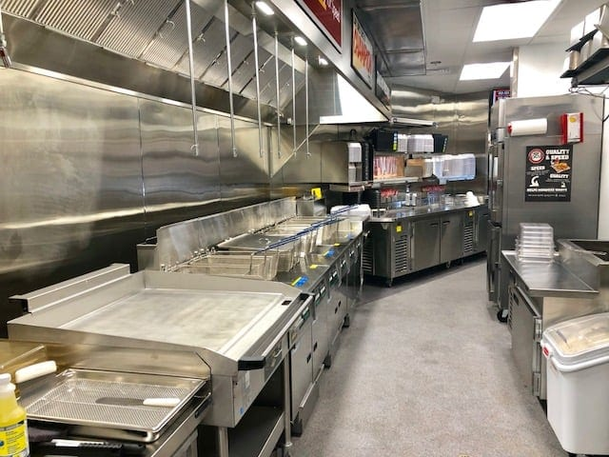**List the major operating equipment that you will need to purchase or lease**

Raising Cane’s restaurants primarily produce fried food, therefore one of the first sets of equipment we must purchase will be deep fryers. In addition to this, our location will need refrigerators, freezers, order screens, point of sale systems, food preparation counters, food storage systems for vegetables and meat, cash registers, tables and chairs, safety equipment (such as gloves and hair nets), cleaning equipment, condiment dispensers, wireless internet and routers, grills, and toasters.

Figure 7: Picture of what the traditional Raising Cane's kitchen looks like

1. **List major suppliers, location, and payment terms**

Raising Cane’s major supplier of chicken is OK Foods, one of the world's largest fully integrated chicken producer. They operate all throughout the United States, so we will be contacting them and acquiring chicken for our restaurant. OK Foods company headquarters is 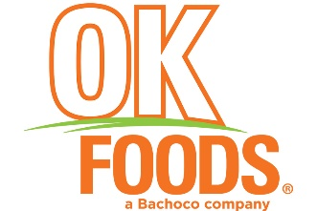located in Fort Smith, Arizona, meaning we will be purchasing poultry meat to be shipped to our location. When it comes to gathering equipment for our location, we will be using FoodServiceEquipmentRental.com to make purchases. This website owns various kitchen equipment we will need for our location. The website has the option of either renting the equipment weekly or paying full price for it.

Figure 8: OK Foods logo

1. **Identify other outside resources used or needed to fulfill customer requirements**

Since Raising Cane’s has various suppliers already, not much additional outside resources will be needed. One form of additional resources we would need would be decoration, such as posters, paintings, and pictures, which all Raising Cane’s restaurants are filled with. These decorations will create a better atmosphere for the customers and make them feel more comfortable and relaxed. Bathroom supplies would also be another resource we would need for our location. These supplies would include toilet paper and soap.

1. **Describe quality control procedures**

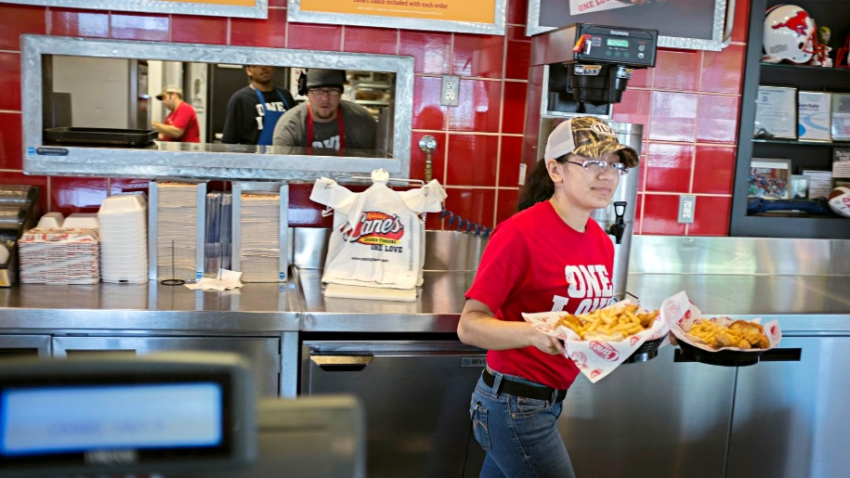Raising Cane’s restaurants are well known for their high-quality food and service. We plan on maintaining this reputation by implementing weekly check-ups on food production, employee service, and kitchen tidiness. At the end of every week, the kitchen manager will survey how the food is produced at our location to ensure it is being produced correctly and effectively. In addition to this, the head manager will also be surveying how each employee member treats the customers and writing down any issues they have noticed in each employee’s service. Lastly, in order to maintain a clean kitchen, there will be a weekly inspection of the kitchens where the managers must rate its tidiness. With all these weekly examinations, our location will function effectively.

Figure 9: Raising Cane's employees working

1. **Describe the availability of skilled labor to meet your company needs**

Skilled labor will not be needed at our restaurant due to the fact that Raising Cane’s is a fast-food restaurant and the franchisees, Kyle Hanson, Jorge Valdez, and Jayden Lazarus, will be the ones dealing with the business aspect of the location. Our employees will likely consist of high school students and young adults who will be paid minimum wage. These employees will take part in a one-week training course where they will learn the basics of handling restaurant equipment, restaurant operations, as well as how to communicate with customers. These workers will have the option of helping with the preparation of our future community events, such as beach clean-ups and charity runs. By doing this, the workers will receive additional pay. As our employees become more experienced in their jobs, they may be subjected to pay raises.

1. **Describe the type and extent of necessary training that will be required to upgrade the skills of labor and administrative employees and the estimated cost**

As explained previously, all employees must attend a week-long training program where they learn how to operate the various restaurant equipment depending on their position, such as the register, point of sale system, deep fryer, toaster, and grill, and what it means to be a member of the Raising Cane’s family. The future employees will also learn about the company’s rules and regulations, how to prepare the food, and how to properly interact with customers. This training will take place before opening hours and will cost around $500 per employee.

1. **Projected number of full-time and part-time employees**

Our location will have a projected total of 15 employees. Seven employees will be in the kitchen preparing the food, three will be in charge of cleaning the dishes, and three will be manning the cash registers and taking orders. There will be two full-time managers, one who will oversee the kitchen staff and another who will review customer satisfaction. When it comes to hiring employees, we will be choosing those who show the most determination and passion.

1. **Organizational Chart**

The organizational chart below shows the different job positions at our Raising Cane’s location.

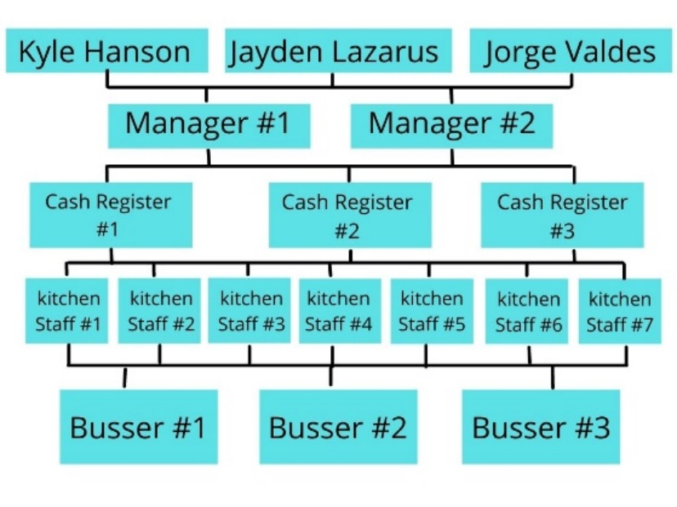

Figure 10: Chart showing the available job positions at our restuarant

**X. Financial Plan and Data**

1. **Describe the company’s sales and profit trends**

Raising Cane’s has been incredibly successful in the past few years, even pushing successfully through the COVID-19 pandemic. The company has amassed a massive customer base, creating the potential for unparalleled growth. In 2020 alone, the company totaled $1.5 billion in total sales and over $500 million in revenue. With their average sales-per-unit reaching $3.6 million, the company is expected to see an 11.4% increase in units and an increase in total sales anywhere between 17.5% and 22.5%.

1. **Outline your strategy and timing for obtaining capitol**

Our plan to acquire the capital needed to start the franchise would be to take out a small business loan for around $2,850,000. This would primarily be to cover the cost of purchasing the physical location (currently valued at $1,734,280 by the city of Fort Lauderdale), equipment costs (estimated around $780,000), and franchising fees ($45,000).. The remainder of the cash (around $440,720) would go into initial food costs and employee salaries, as well as to serve as an emergency fund for the business. This loan would be paid back monthly over the span of 10 years at an estimated interest rate of 2.75%.

1. **Two-year projected operating statement**

In the first two years of operation, our biggest operations expenses will be employee salaries (estimated at around $977,410.67 annually), loan payments ($308,250 annually), royalties (5%), and advertising fees (4%). Assuming our location’s sales matches that of the company average of $3.6 million annually, these four expenses alone would total $2,895,321.34 over these two years ($1,954,821.34 for employee salaries, $616,500 for loan installments, $180,000 for royalties, and $144,000 for advertising fees). We can also expect to pay about $30,033.80 for utilities for both years ($10,852.50 annually for power and gas, and $4,164.40 annually for water).

1. **One-year projected cash flow statement**

Considering several factors including but not limited to the high traffic nature of the area, its proximity to tourist destinations and affluent neighborhoods, and its proximity to countless worksites; I would estimate first year sales at $4 million. Using the figures listed above having adjusted the royalty and advertising fees to the new sales figure, our expenses our first year would total up to $1,660,677.57. Working under the assumption that the costs for the ingredients for the menu items themselves make up 40% of the total sales figure, our total revenue by the end of the first year is expected to be somewhere around $734,322.73.

**XI. Conclusion**

Raising Cane’s is a very successful chicken company that will fit perfectly into the busy environment of Fort Lauderdale, Florida. Overall, in order for our location to function properly, we will need to acquire a Small Business Administration 7(a) loan of $2,850,000 alongside our individual investments totaling $150,000. The first portion of this loan will be used to cover the cost of our location, which is valued at $1,734,280. The cost of restaurant equipment will be around $780,000, this includes soda machines, cash registers, stoves, fryers, computers, and any other necessary equipment for our restaurant to function. $45,000 will be used to cover the cost of the Raising Cane’s franchise fee. After all these payments have been made, this leaves us $440,720 to be spent on the initial costs of food and the salaries for our employees. After all these necessary investments for our location, our location will be fully operational. If all our data collected is correct, then we will be project to earn a net revenue of around $4 million in our first year of operation, with the future years only increasing this number.

**Bibliography**

Credera. (2021, December 5). *Raising cane's: Chicken fingers: Cane's sauce RSS*. RaisingCanesChickenFingers. Retrieved from https://www.raisingcanes.com/our-story.

City of Fort Lauderdale gis web application. (n.d.). Retrieved from <https://gis.fortlauderdale.gov/propertyreporter/?extent=-8921061%2C3011313%2C-8920487%2C3011590%2C102100>.

09, R. R. | M. (2021, October 6). *Raising Cane's debuts New Restaurant Partner Program*. Nation's Restaurant News. Retrieved from https://www.nrn.com/quick-service/raising-cane-s-debuts-new-restaurant-partner-program.

Kelso, A. (2020, March 13). *Raising cane's now offering 'industry-leading' compensation, including the chance to make $1 million*. Forbes. Retrieved from https://www.forbes.com/sites/aliciakelso/2020/03/13/raising-canes-is-now-offering-industry-leading-compensation-including-the-chance-to-make-1m/?sh=2f335e135858.

Kelso, A. (2020, April 6). *Here’s How Raising Cane’s Plans To Keep Its Entire Staff Employed Through The Coronavirus Crisis.* Retrieved from [Here’s How Raising Cane’s Plans To Keep Its Entire Staff Employed Through The Coronavirus Crisis (forbes.com)](https://www.forbes.com/sites/aliciakelso/2020/04/06/heres-how-raising-canes-plans-to-keep-its-entire-staff-employed-through-the-coronavirus-crisis/?sh=5f33d1c259e7)

*The Pros and cons of a raising cane's franchise*. Franchise Know How - Review of Small Business Opportunities for Passive Income. (2021, September 17). Retrieved from https://www.franchiseknowhow.com/pros-cons-raising-cane-franchise/.